logo (1)

**University of the People**

CS 2205 Web Programming 1

Instructor – Hemant Sharma

AY2023-T3

Learning Journal – Unit 3

Uuganbayar Naranbaatar

July 3rd, 2023

**Part A**

*Question 1:*

I created two identical forms for a simple contact section. The forms ask users for their name, email address, and message, and they both have a submit button. The only difference between the two forms is the HTTP method used. The first form uses the GET method, and the second form uses the POST method.

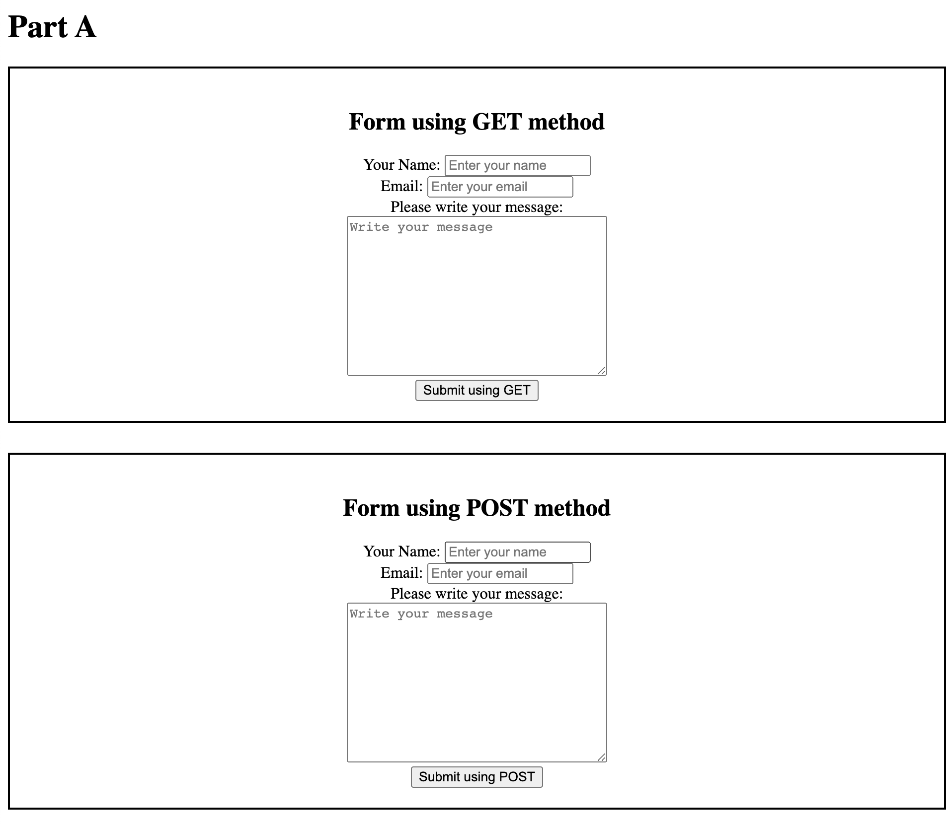

Figure 1 – Forms

*Question 2*

The output of the GET method form appends all the input values to the URL, which makes this method less secure for sensitive information. For example, if a user enters their name, email address, and message into a GET method form, the URL will look something like this:

* file:///index.html?name=GET+Method&email=get%40method.com&message=This+is+message+using+GET+Method.

This information is then sent as a HTTP request to the server, which means that it could be intercepted by a third party. Additionally, the information will be stored in the user's browser history, so anyone who has access to their browser could see it.

For this reason, it is important to avoid using the GET method for forms that contain sensitive information.

On the other hand, POST method is more secure and does not append sensitive information on the URL. Instead, it will send the data as part of HTTP request payload. Here is an example of the output of a POST method form obtained from Chrome Developer tool: A screenshot of a computer

Figure 2 - POST method output

**Part B**

*Question 1*

I chose to use radio buttons for the marital status field because they are more visible to the user and easier to choose from than a dropdown menu.

Here is the code for the form:

<div>

<form>

<label>Choose your marital status:</label><br>

<div class="left-align">

<input type="radio" id="single" name="mStatus" value="single">

<label for="single">Single</label><br>

<input type="radio" id="married" name="mStatus" value="married">

<label for="married">Married</label><br>

<input type="radio" id="widow" name="mStatus" value="widow">

<label for="widow">Widow</label><br>

<input type="radio" id="none" name="mStatus" value="none">

<label for="none">Prefer not to say</label><br>

</div>

</form>

<br>

</div>

Figure 3 - Marital Status

*Question 2*

For this question, I used a dropdown menu because there are only two possible answers. However, instead of including only two options in the code, I added a third option that is disabled, hidden, and selected by default. This option is a placeholder that instructs users to select an option. The message "Select an Option" is visible when the page loaded answer is not selected.

<div>

<form>

<label for="diabetes">Do you have any medical history of Diabetes?</label>

<select name="diabetes" id="diabetes">

<option value="default" selected disabled hidden>Select an Option</option>

<option value="yes">Yes</option>

<option value="no">No</option>

</select>

</form>

<br>

</div>

Figure 4 - Medical Question

*Question 3*

To complete this task, I created a simple form with a label and text area for users to write their reviews. I also included a button to submit the review. Since the review could be long for any given user, I decided to use the POST method along with the form. The POST method does not have a size limitation, so it is ideal for forms that need to collect large amounts of data.

<div>

<form action="/index.html" method="POST">

<label for="review">Write your review:</label><br>

<textarea name="review" id="review" cols="30" rows="10" placeholder="Write your

feedback for your recent food delivery service with us..."></textarea>

<br>

<input type="submit" value="submit">

</form>

<br>

</div>

Figure 5 – Review

*Question 4*

On the last question, I used a dropdown menu because there are 8 choices. If I used radio buttons, it would take up a lot of space, which would be a problem if there were many other questions on the form. Therefore, I decided to use a dropdown menu, which is more space efficient.

<div>

<form>

<label for="fav-sport">Select your favorite sport:</label>

<select name="fav-sport" id="fav-sport">

<option value="default" selected disabled hidden>Select an Option</option>

<option value="basketball">Basketball</option>

<option value="football">Football</option>

<option value="swimming">Swimming</option>

<option value="chess">Chess</option>

<option value="esport">eSport</option>

<option value="bowling">Bowling</option>

<option value="tennis">Tennis</option>

<option value="archery">Archery</option>

</select>

</form>

</div>



Figure 6 - Select Sport

**Full HTML Code**

<!DOCTYPE html>

<html lang="en">

<head>

<meta charset="UTF-8">

<meta name="viewport" content="width=device-width, initial-scale=1.0">

<title>Learning Journal 3</title>

<style>

div {

border: 2px solid black;

margin-bottom: 30px;

padding: 20px;

justify-content: center;

text-align: center;

}

.left-align {

border: none;

text-align: left;

width: fit-content;

margin: 0 auto;

padding-top: 0;

}

</style>

</head>

<body>

<h1>Part A</h1>

<div>

<h2>Form using GET method</h2>

<form action="/index.html" method="GET">

<label for="name">Your Name:</label>

<input type="text" name="name" id="name" placeholder="Enter your name"><br>

<label for="email">Email:</label>

<input type="email" name="email" id="email" placeholder="Enter your email"><br>

<label for="message">Please write your message:</label><br>

<textarea name="message" id="message" cols="30" rows="10" placeholder="Write your message"></textarea><br>

<input type="submit" value="Submit using GET">

</form>

</div>

<div>

<h2>Form using POST method</h2>

<form action="/index.html" method="POST">

<label for="name">Your Name:</label>

<input type="text" name="name" id="name" placeholder="Enter your name"><br>

<label for="email">Email:</label>

<input type="email" name="email" id="email" placeholder="Enter your email"><br>

<label for="message">Please write your message:</label><br>

<textarea name="message" id="message" cols="30" rows="10" placeholder="Write your message"></textarea><br>

<input type="submit" value="Submit using POST">

</form>

</div>

<h1>Part B</h1>

<div>

<form>

<label>Choose your marital status:</label><br>

<div class="left-align">

<input type="radio" id="single" name="mStatus" value="single">

<label for="single">Single</label><br>

<input type="radio" id="married" name="mStatus" value="married">

<label for="married">Married</label><br>

<input type="radio" id="widow" name="mStatus" value="widow">

<label for="widow">Widow</label><br>

<input type="radio" id="none" name="mStatus" value="none">

<label for="none">Prefer not to say</label><br>

</div>

</form>

<br>

</div>

<div>

<form>

<label for="diabetes">Do you have any medical history of Diabetes?</label>

<select name="diabetes" id="diabetes">

<option value="default" selected disabled hidden>Select an Option</option>

<option value="yes">Yes</option>

<option value="no">No</option>

</select>

</form>

<br>

</div>

<div>

<form action="/index.html" method="POST">

<label for="review">Write your review:</label><br>

<textarea name="review" id="review" cols="30" rows="10" placeholder="Write your feedback for your recent food delivery service with us..."></textarea>

<br>

<input type="submit" value="submit">

</form>

<br>

</div>

<div>

<form>

<label for="fav-sport">Select your favorite sport:</label>

<select name="fav-sport" id="fav-sport">

<option value="default" selected disabled hidden>Select an Option</option>

<option value="basketball">Basketball</option>

<option value="football">Football</option>

<option value="swimming">Swimming</option>

<option value="chess">Chess</option>

<option value="esport">eSport</option>

<option value="bowling">Bowling</option>

<option value="tennis">Tennis</option>

<option value="archery">Archery</option>

</select>

</form>

</div>

</body>

</html>